REST API Web Services

REST: Representational State Transfer

Introduction

POJO: Plane Old Java Object
REST API is used to send the state of an object (consider WTObjects information on Windchill) from Server to Client(In my case Windchill to TWX).

How to create a Resource Class

- Just created an Alien class and on top of that we have written @XmlRootElement as we are returning the output of resource in xml format.
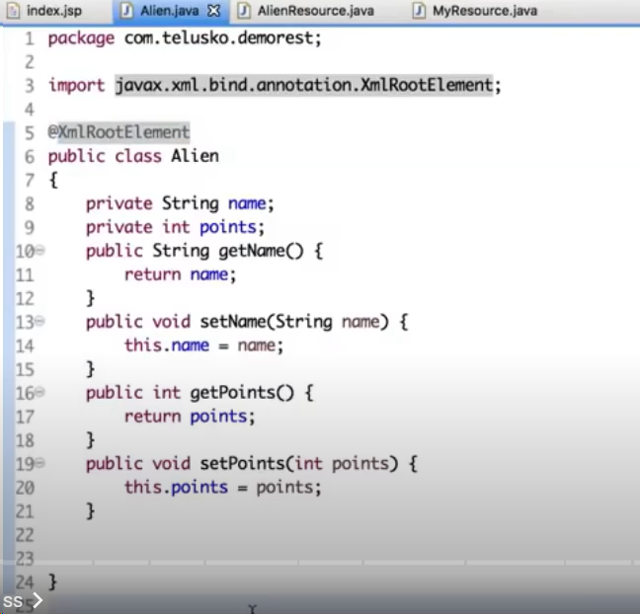

- And we created the Alien Resource where we are getting a method called getAlien() with annotation @GET because we are sending a get request and annotation @Produces(MediaType.APPLICATION_XML) to mention what we are producing.
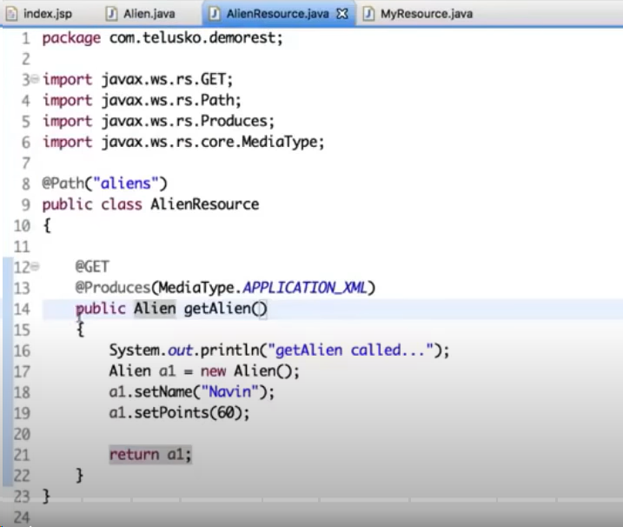

- Below is the output generated which is in XML format.
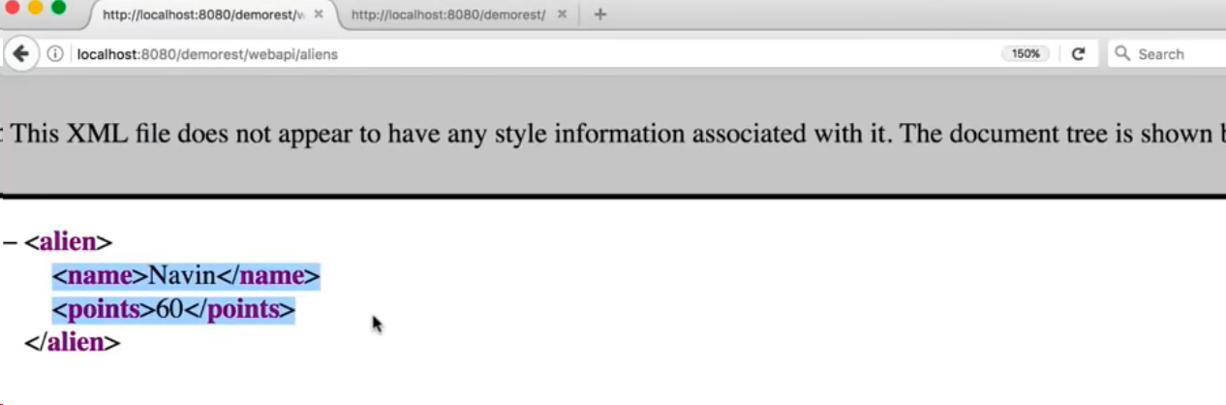

List as Resource

- To get the list of resource update the resource code as shown below.
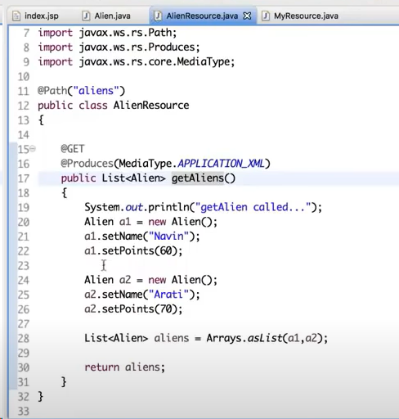

- Below is the output generated in xml format.
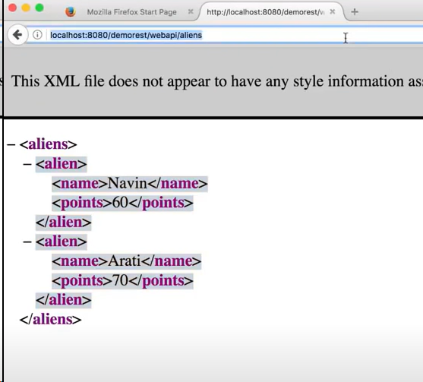

Mock Repository

- Create the repository class (Ntg but a DB) as shown below.
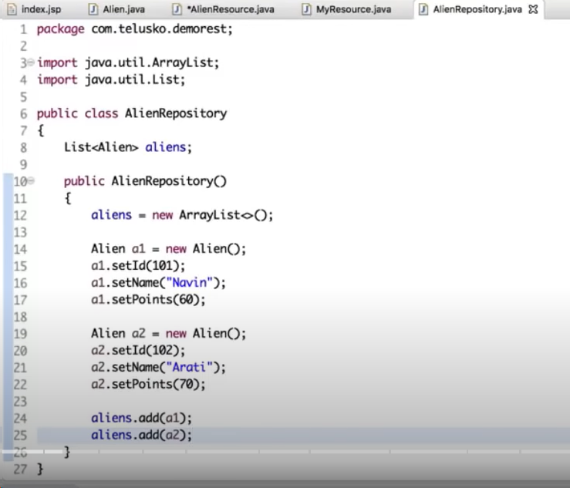
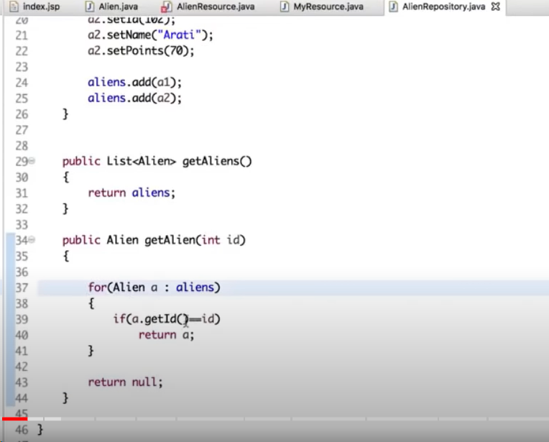

- Update the AlienResource class as shown below.
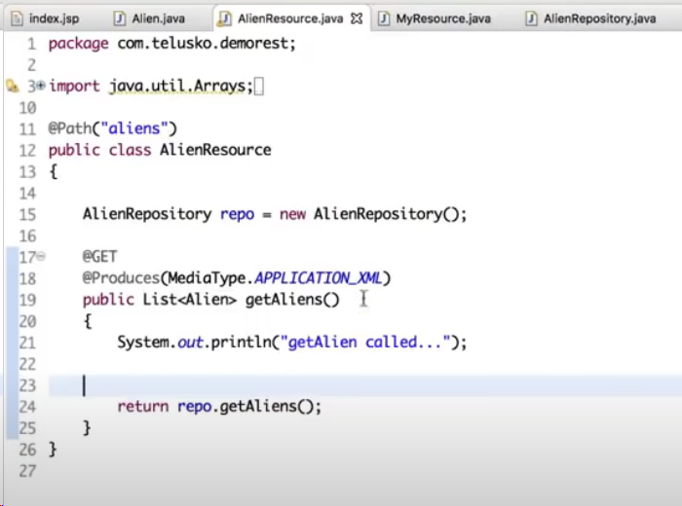

- Output is generated as shown below.
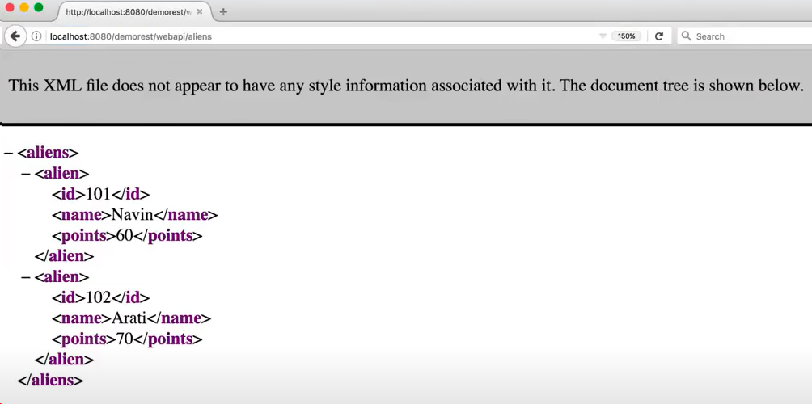

Creating a Resource

@POST: To create a new resource.
@GET: To fetch the resource.
@PUT: To update a resource.
@DELETE: To delete a resource.

- To create a resource, develop the repository logic as shown below.
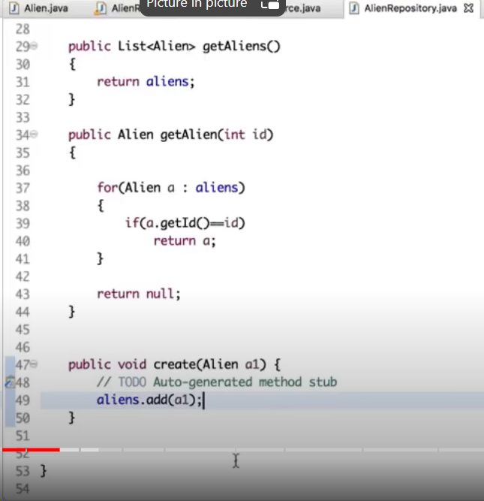

- Then develop the logic for resource code as shown below.
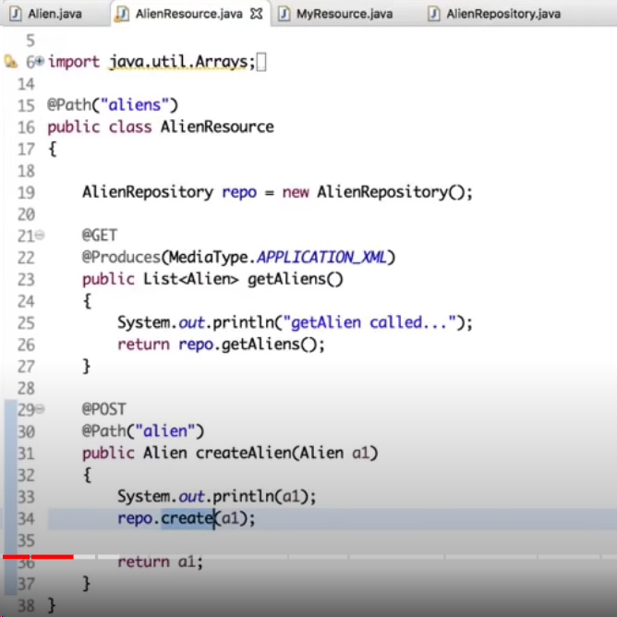

Send a Post Request

